**Load Balancer Tasks**

1. **Configure Classic Load balancer.**

* Go to AWS console
* Click on load balancers
* We can find load balancers (ALB,NLB,GLB), and Classic load balancer
* Click on classic load balancer and click on create load balancer

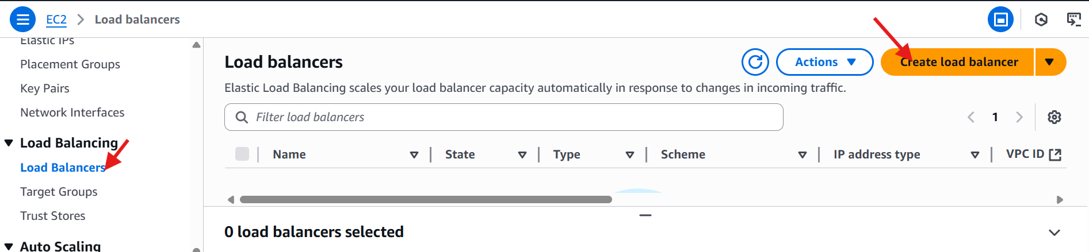

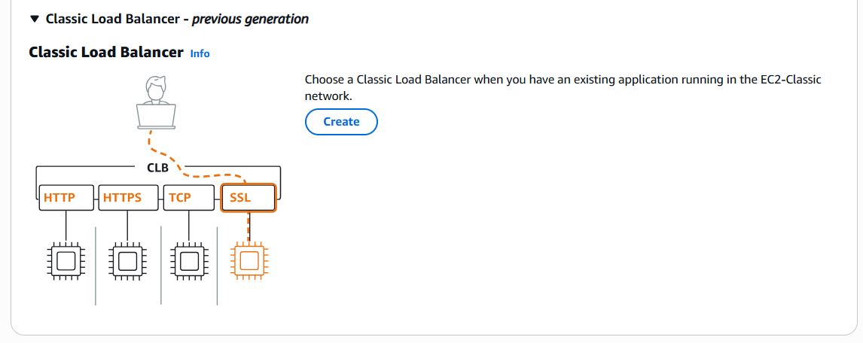

* Give load balancer name (Classic-load-balancer)
* In scheme we have internet-facing 🡪 it is public

Internal 🡪 It is private.

* Select internet-facing.
* Select VPC and subnets
* Select security groups
* Select listeners protocol and port number
* And click on create load balancer.

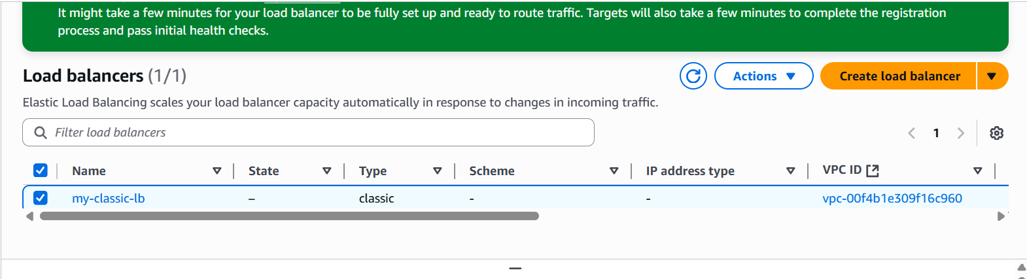

* Launch 2 ec2 instances with same VPC
* And in object file write some code like

#!/bin/bash

Sudo yum –y install httpd

echo “welcome to Techie Horizon-01” >> /var/www/html/index.html

sudo systemctl start httpd.

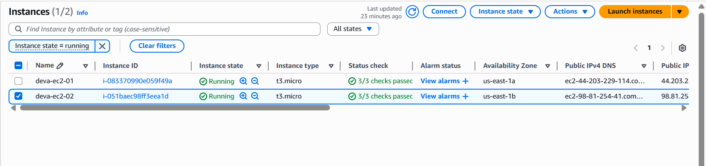

* Click on target instances
* And click on manage instances

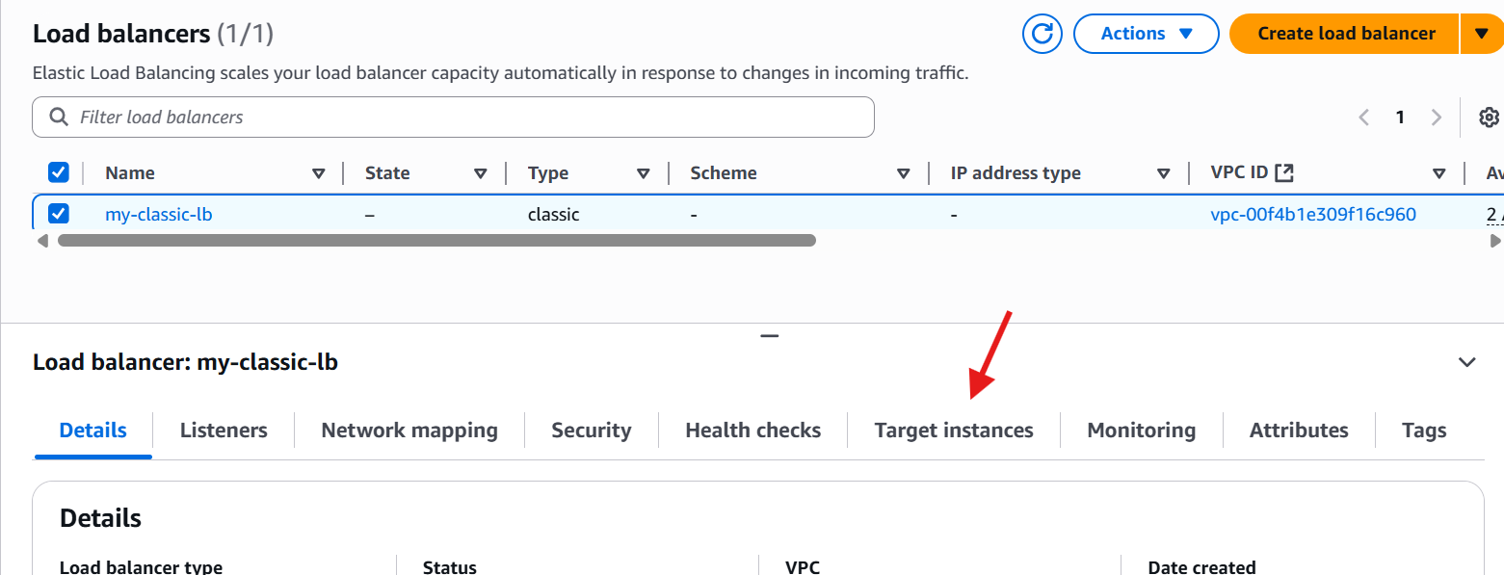

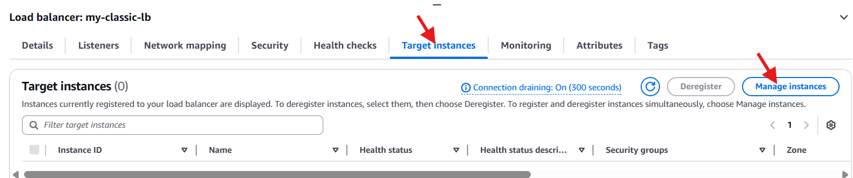

* Add the 2 instances in target instances.
* And check the health status.

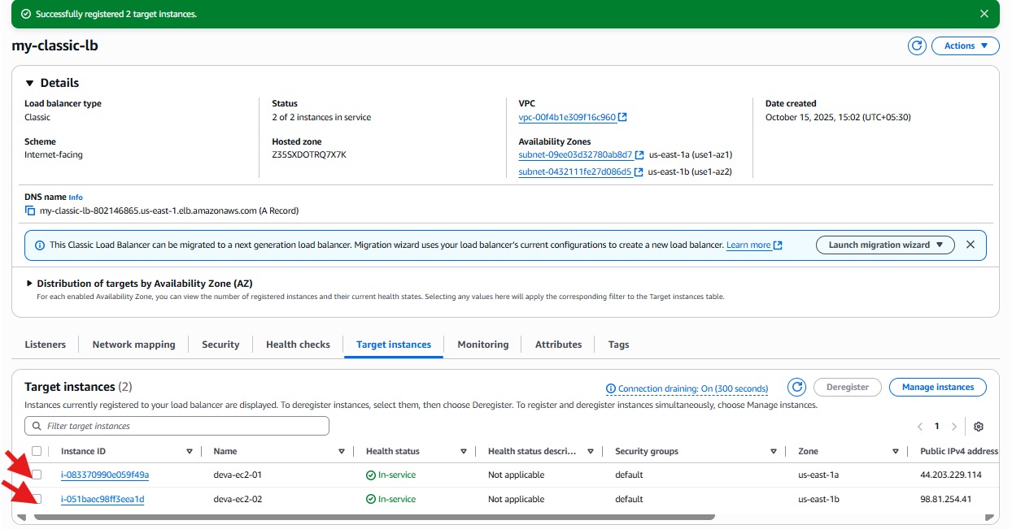

* After adding instances, go to load balancer and copy the DNS URL and paste it in the browser and enter, it shows like

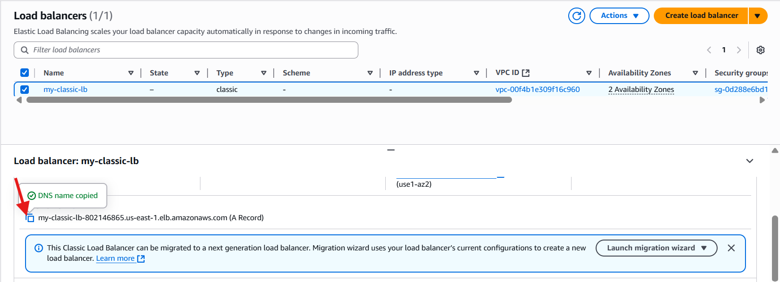

* Here the results:

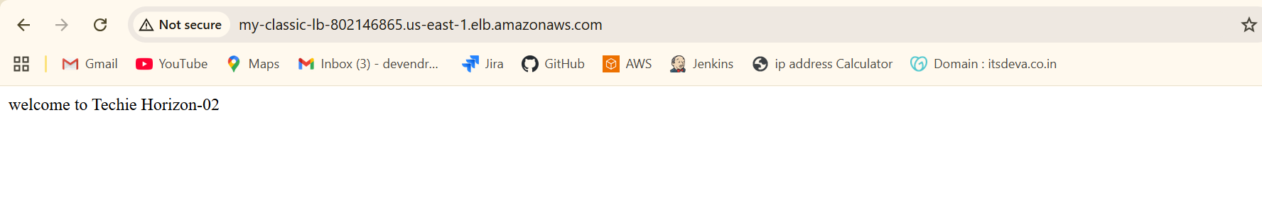

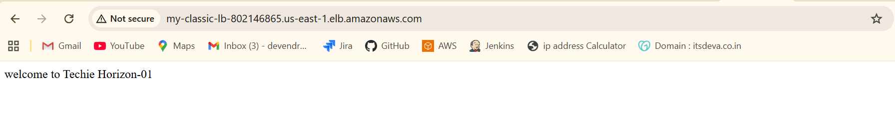

1. **Configure Application Load balancer.**
   * Go to AWS console
   * Click on load balancers
   * We can find load balancers (ALB,NLB,GLB), and Classic load balancer
   * Click on Application load balancer and click on create load balancer

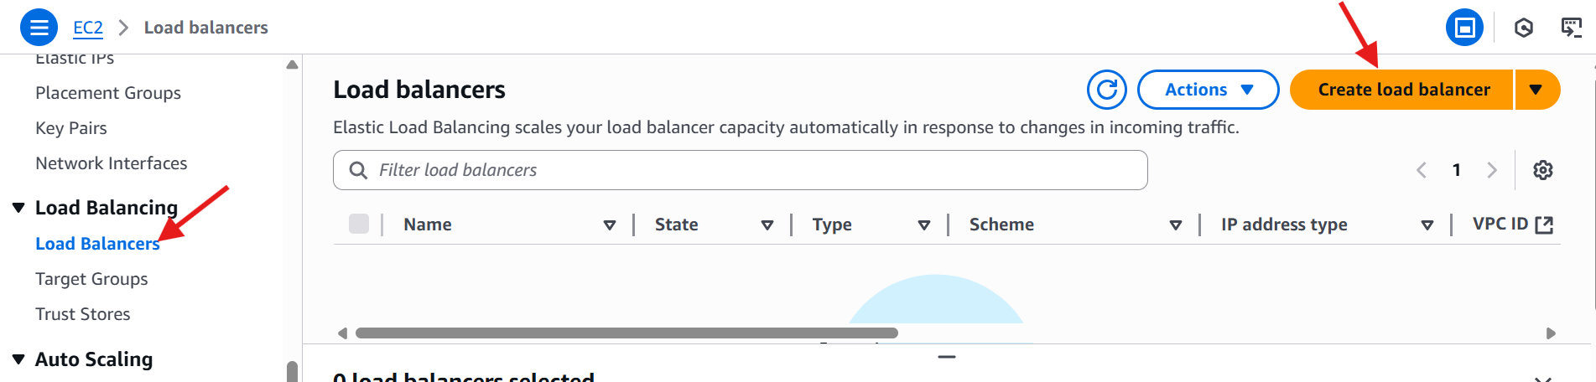

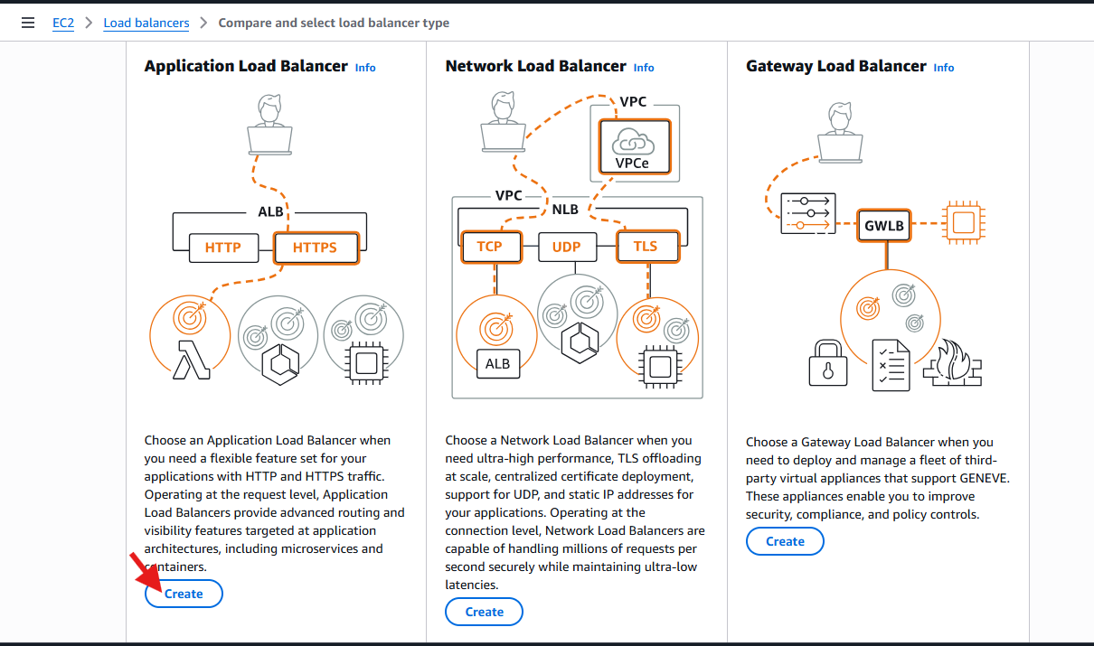

* Give load balancer name (Classic-load-balancer)
* In scheme we have internet-facing 🡪 it is public

Internal 🡪 It is private.

* Select internet-facing.
* Select VPC and subnets
* Select security groups
* Select listeners protocol and port number

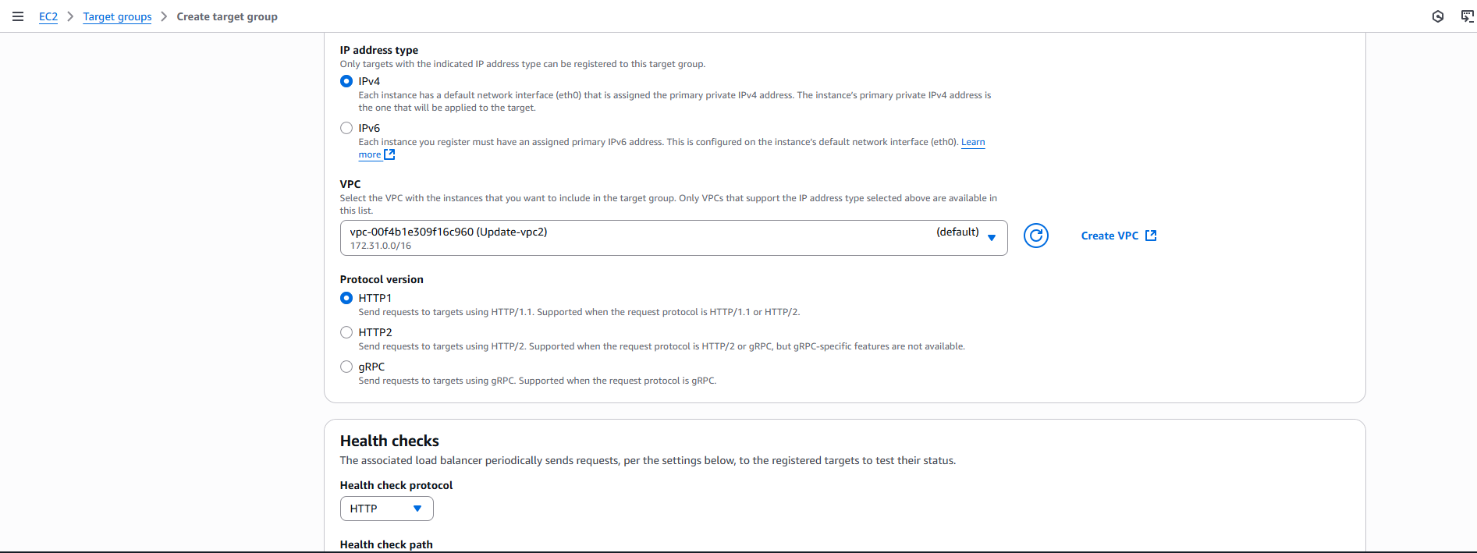

* And in load balancer, we have to give default action like target group.
* Click on create target group.
* Select instances
* Give target group name
* Select VPC(default)
* Health check protocol(HTTP)
* Click on next
* And you have to select the instances to target.
* Click o include as pending below
* Click on create target group

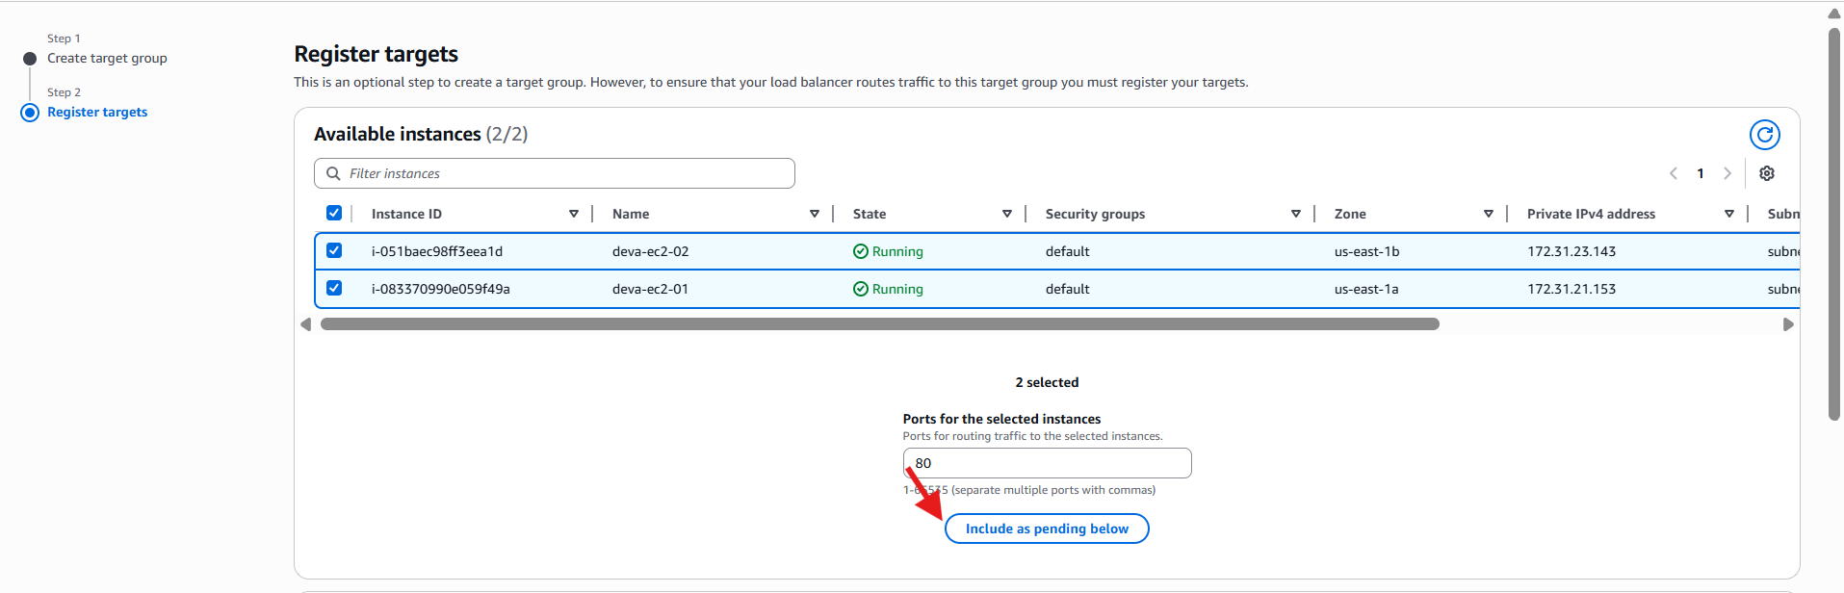

* Here the target group.



* Go to load balancer and give the target group
* Click on create load balancer.

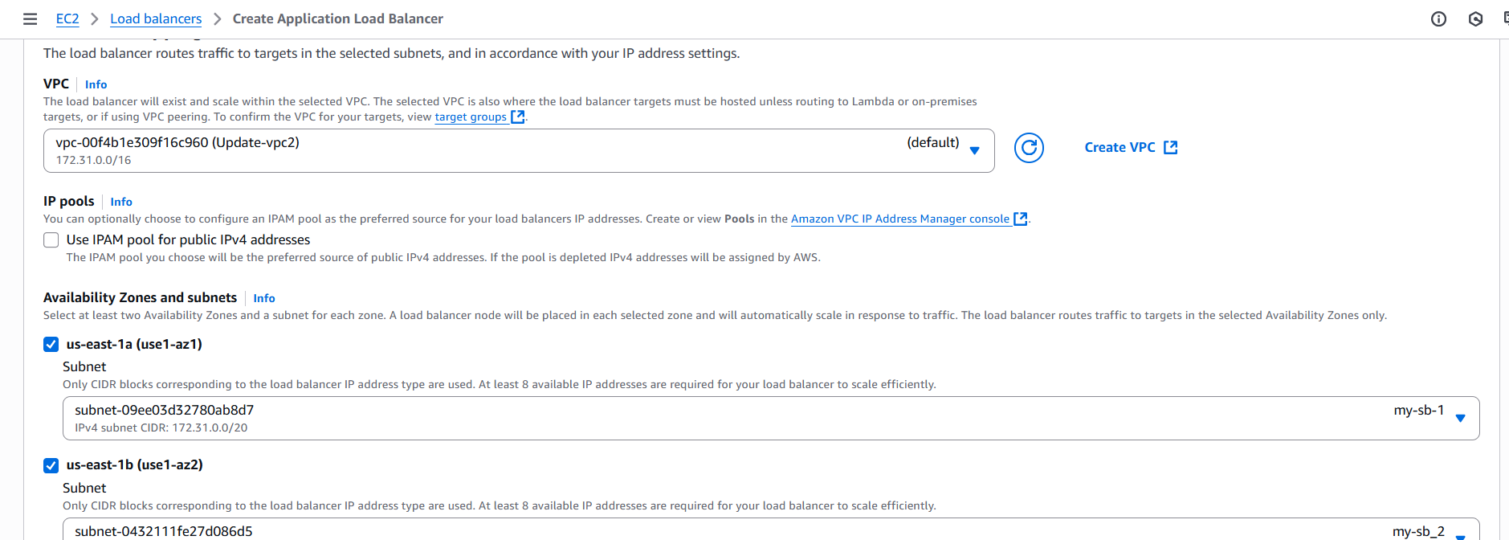

* And check the instances in target group.
* Once it comes healthy

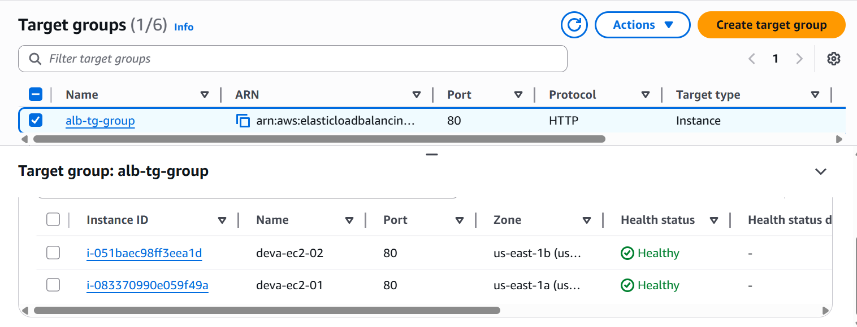

* Go to load balancer and copy the DNS URL and paste it in the browser and check.

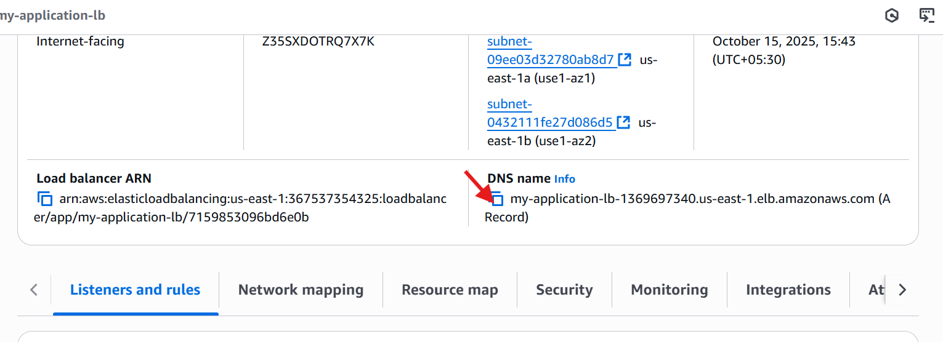

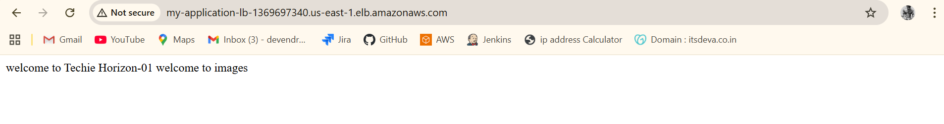

1. **Configure Network Load balancer.**
   * Go to **AWS Management Console → EC2 → Load Balancers**
   * Click **Create Load Balancer**
   * Choose **Network Load Balancer**, then click **Create**



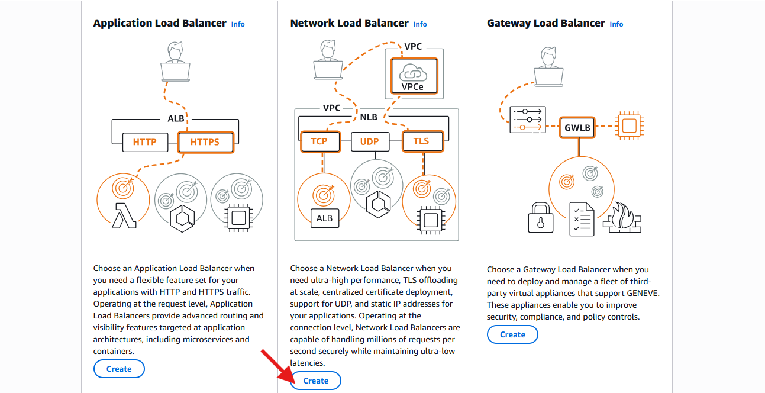

* Give load balancer name (network-load-balancer)
* In scheme we have internet-facing 🡪 it is public

Internal 🡪 It is private.

* Select internet-facing.
* Select VPC and subnets
* Select security groups
* Select listeners protocol and port number

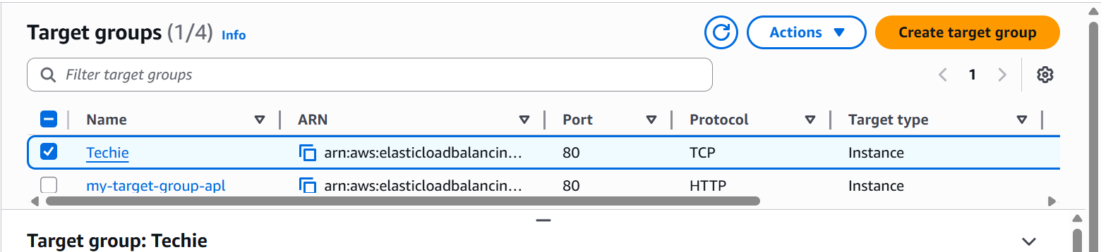

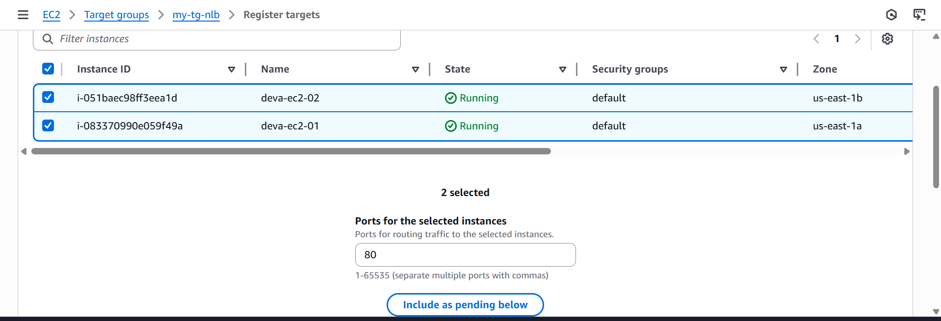

* + Select your **EC2 instances** that you want the NLB to route traffic to
  + Click **Include as pending below**
  + Create one target group.

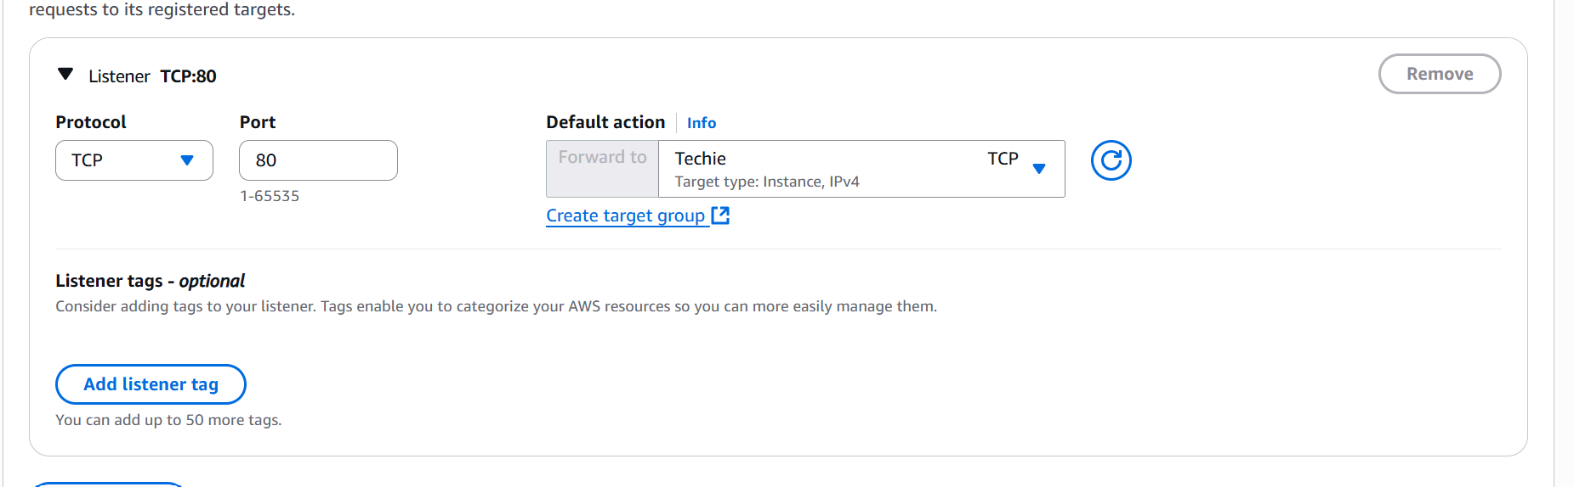

* + Created network load balancer.

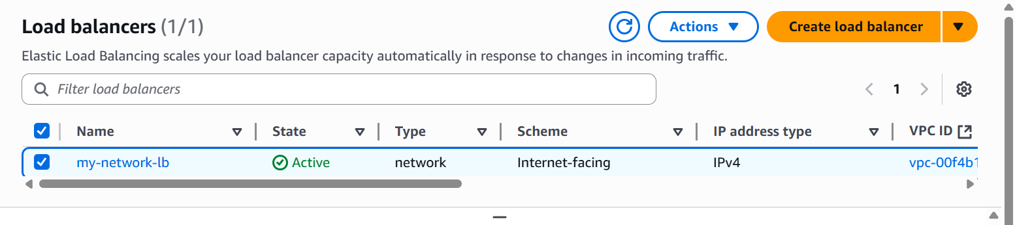

* + And check the health

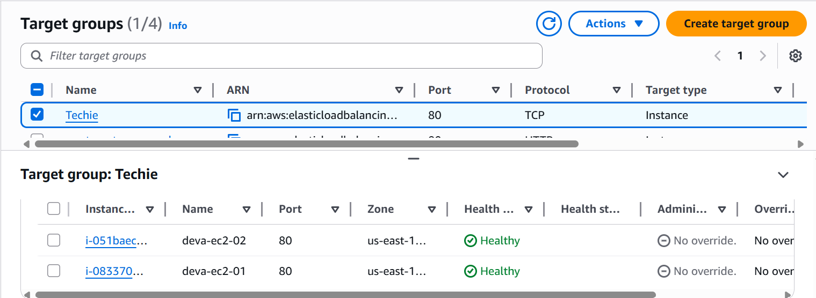

* + Copy the DNS URL of network load balancer
  + Paste it in the browser and check

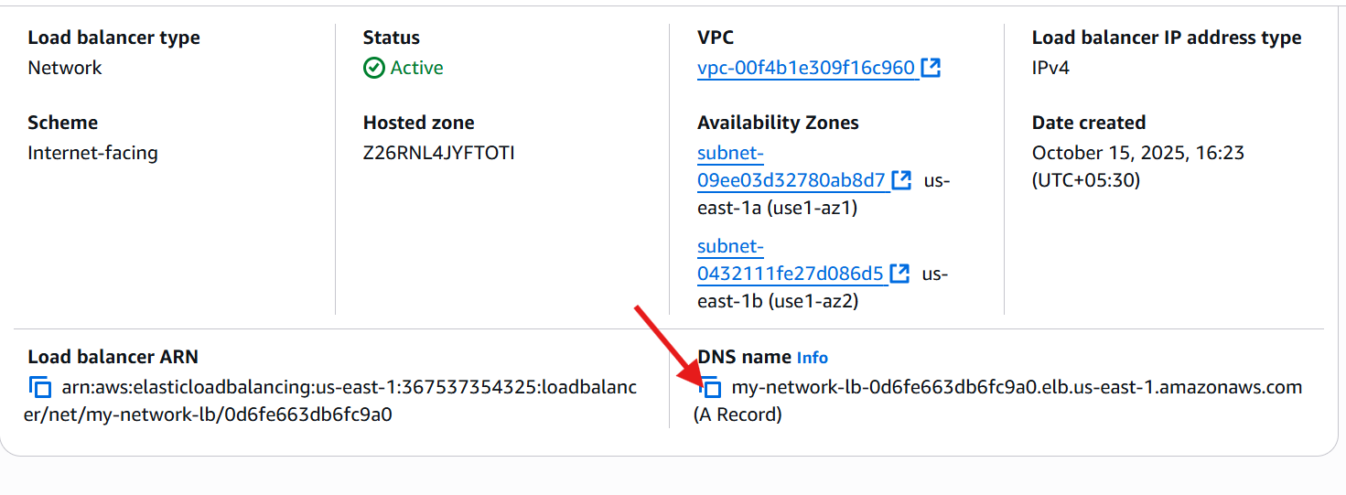

* + Here the results:



1. **Attach SSL for application load balancer.**
2. **Map Application load balancer to R53.**
   * Create application loaded balancer.
   * Then go to route 53
   * Create hosted name with your domain
   * Then crate record
   * And turn alias
   * Then choose the application load balancer
   * Then select your load balancer on it
   * Wait for it’s available.

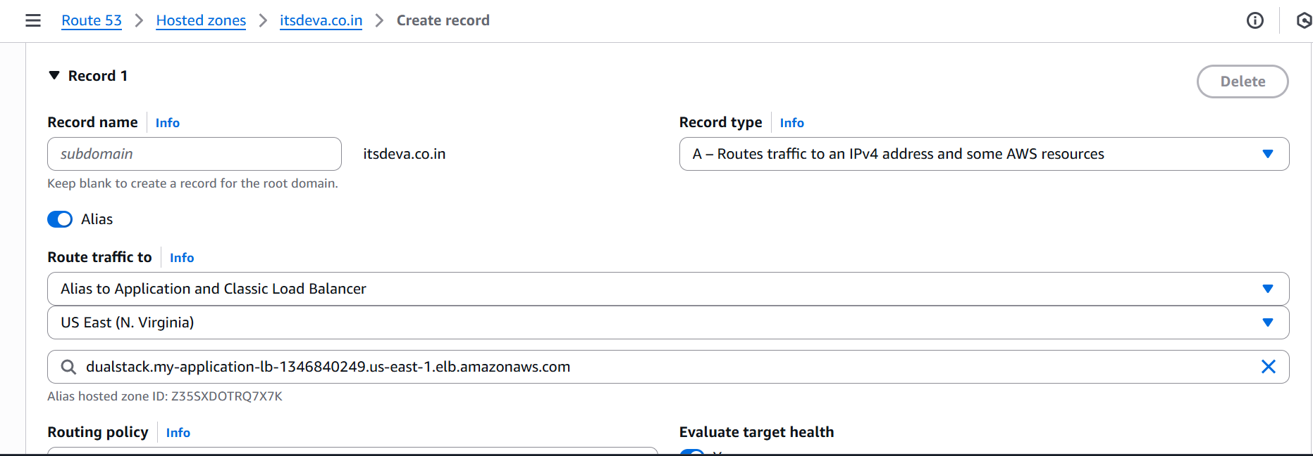

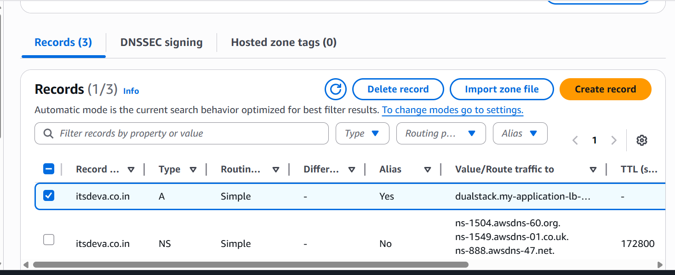

<http://itsdeva.co.in.s3-website-us-east-1.amazonaws.com>

1. **Push the application load balancer logs to S3.**
   * Go to **S3 Console → Create bucket**
   * Name it something like (alb-logs-itsdeva).
   * Select region
   * Click on create bucket.

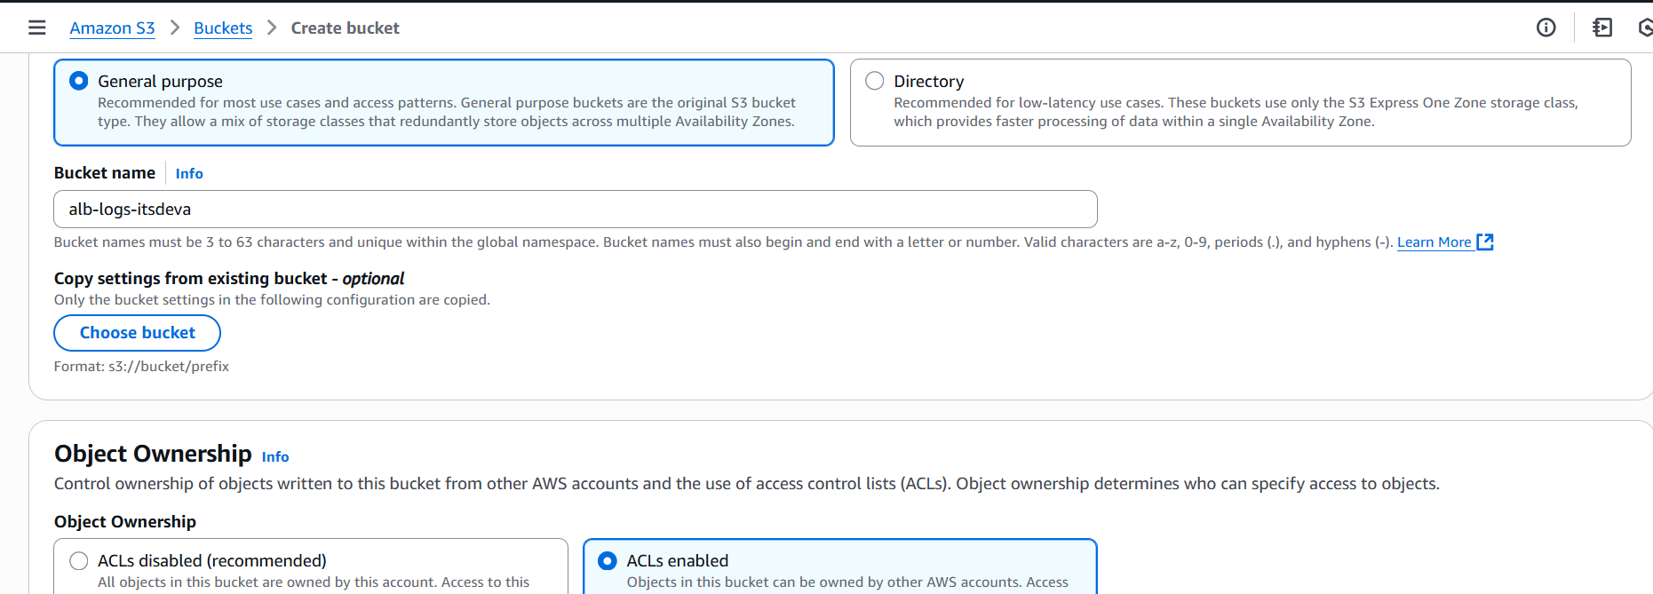

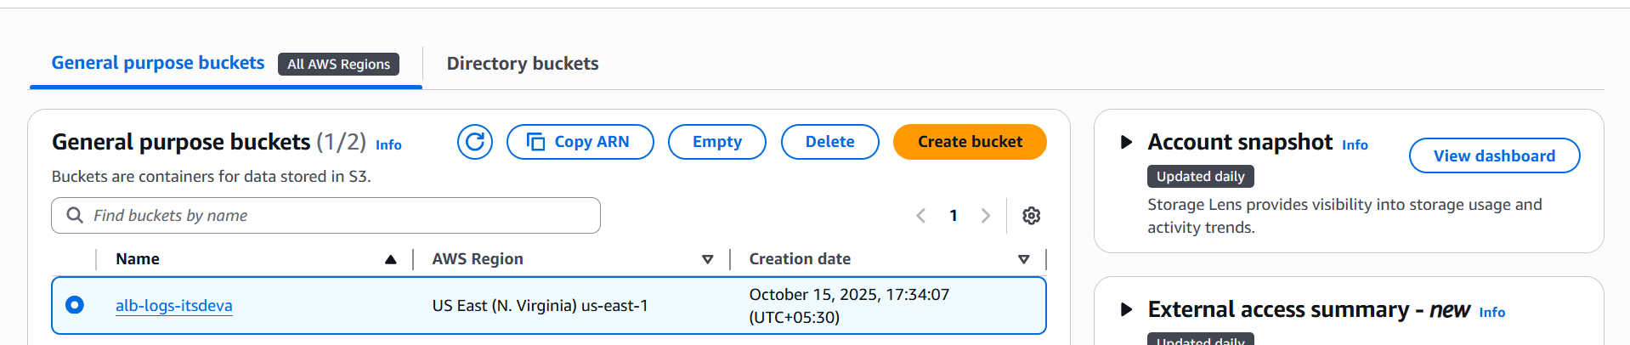

* + Go to the **permissions** in s3 bucket.
  + Then edit a policy and use reference from Google
  + Here the script are:

{

"Version": "2012-10-17",

"Statement": [

{

"Sid": "AWSALBLogDelivery",

"Effect": "Allow",

"Principal": {

"Service": "logdelivery.elasticloadbalancing.amazonaws.com"

},

"Action": "s3:PutObject",

"Resource": "arn:aws:s3:::alb-logs-itsdeva/AWSLogs/*",

"Condition": {

"StringEquals": {

"aws:SourceAccount": "YOUR_AWS_ACCOUNT_ID"

},

"ArnLike": {

"aws:SourceArn": "arn:aws:elasticloadbalancing:ap-south-1:YOUR_AWS_ACCOUNT_ID:loadbalancer/app/*"

}

}

}

]

}

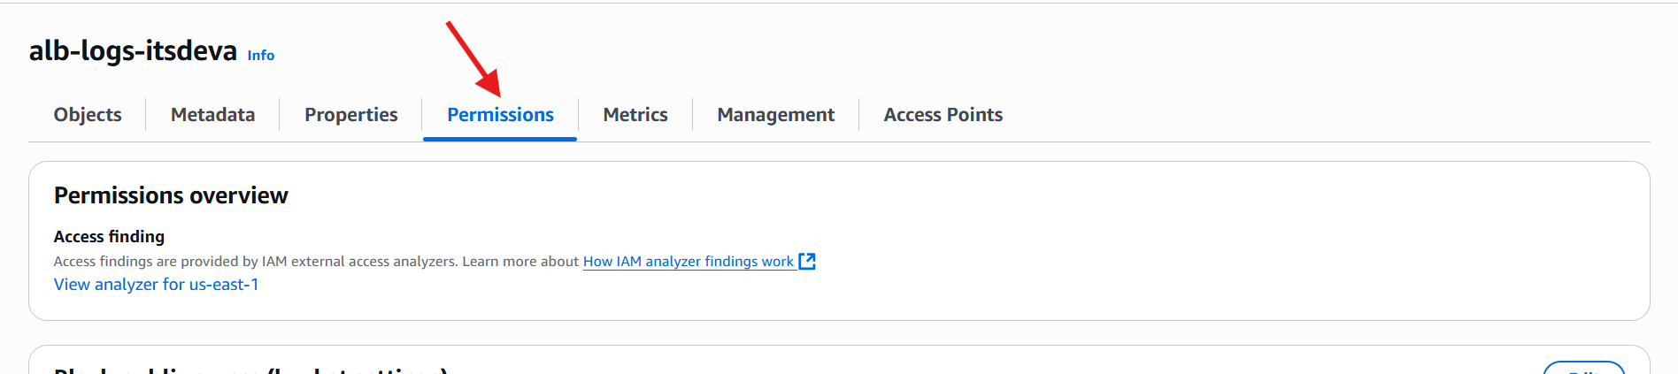

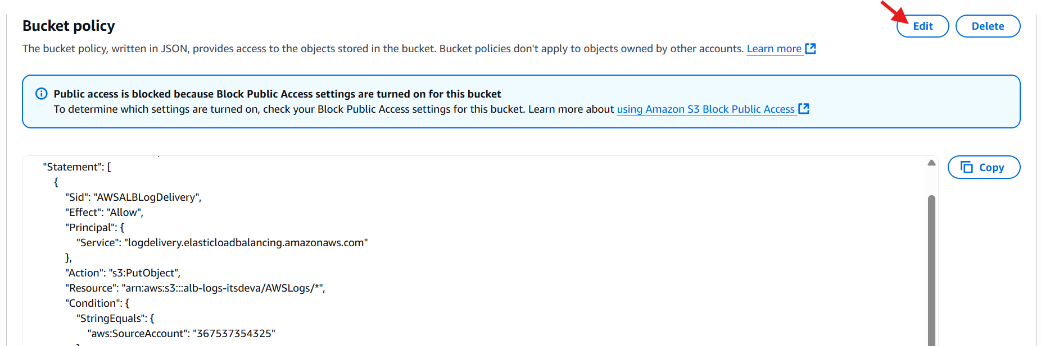

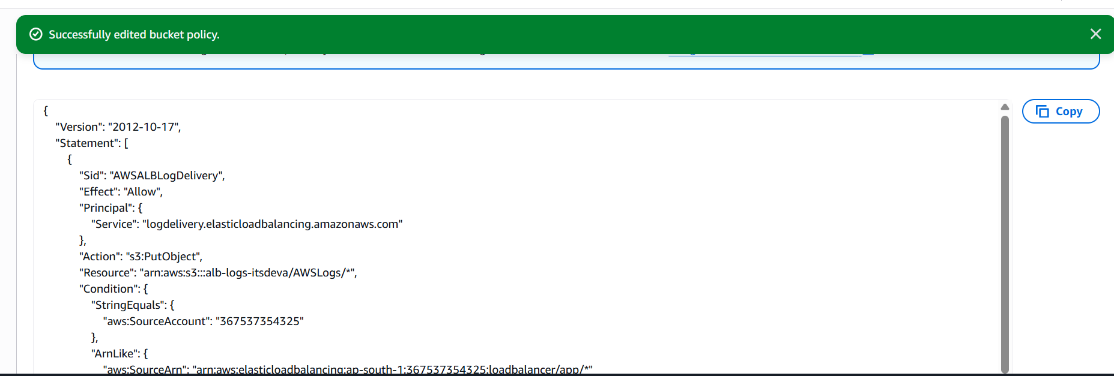

* + Go to **EC2 → Load Balancers → Select your ALB**
  + Click **Attributes tab**
  + Under **Access logs**, click **Edit**
  + Enable **Access logs**
  + **S3 bucket name:** alb-logs-itsdeva
  + Click **Save changes**

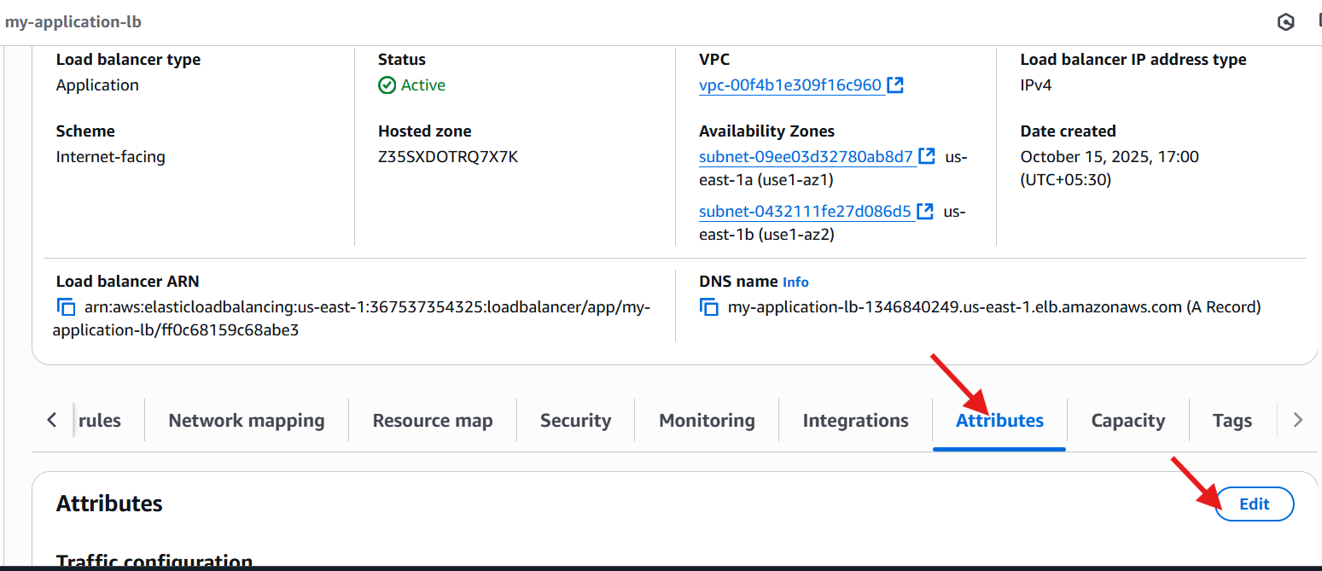

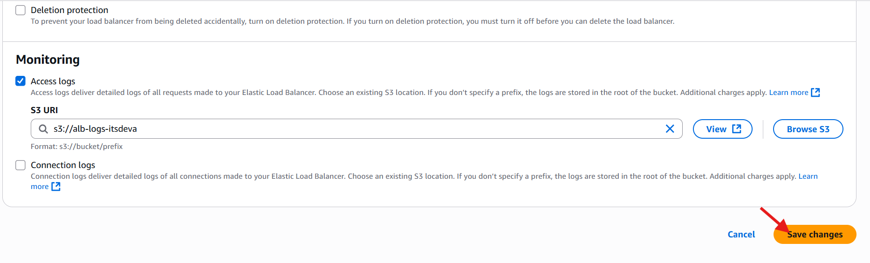

* + Then go back to the s3 bucket refresh the page.
  + Open a object bar here the results are:

